Chapter 14, Problem 102.

Practical RC filter design should allow for source and load resistances as shown in Fig. 14.110. Let R = 4 kΩ and C = 40-nF. Obtain the cutoff frequency when:

(a) R_{s} = 0, R_{L} = ∞,
(b) R_{s} = 1 kΩ, R_{L} = 5 kΩ.

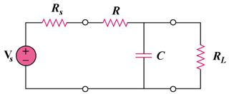

Figure 14.110
For Prob. 14.102.

